UNIVERSAL MUSIC?
By Sebastian von Hoerner
Many astronomers, biologists, and other scientists have tried to answer questions concerning life in space, and we have made many estimates about the possibility of interstellar communications. This may also lead to the amusing question: "About which topics could we probably communicate sensibly with alien civilizations, reaching enough mutual understanding?" If contact is made by radio signals, say, then of course we can talk about electronics and antennas without too much problem. Further on, the common guess is, in decreasing order: mathematics, physics, chemistry, biology, politics, and religion. But where does music come in? How "universal" is it? (Our music, that is.)
There are biological constraints. Perception and experience of our music needs a frequency analyzer in our ear with a large number of separate channels (not just three widely overlapping ones as our eye has); it needs also some non-linear coupling (for the perception of difference-tones), and timbre recognition. Aliens without these devices might show some mild scholarly interest in our explanations but otherwise would not care very much.
But wherever nature had provided all necessities, and where music actually has developed, could we expect it then to be similar to our own? I think yes, at least in some cases and to some extent, because several of our basic principles of music seem to be sufficiently straightforward and general in nature.
First, the division of the octave into 12 equal parts, our well-tempered chromatic scale (which is the common backbone of most other scales) comes in a fairly natural way, provided the ear has a good sense of relative pitch but has no preferred tones or scale. Take some tone as the base; select all tones which have simple frequency ratios to this base, using all prime numbers up to prime p (p=7, for example, yields the ratios 7/6, 7/5,7/4, 6/5, 5/4, 5/3, 3/2 within one octave). Then divide the octave into n equal parts, and demand that all selected tones are closely enough approached (within 1/5 of one such part, say). With this procedure, p=2 gives n=1, p=3 gives n=5, p=5 gives our n=12, while p=7 gives n=p 31. But for p=11, the first good fit occurs with n=270, yielding too many "unwanted" tones. Thus, n=5, 12, and 31 are equally probable.
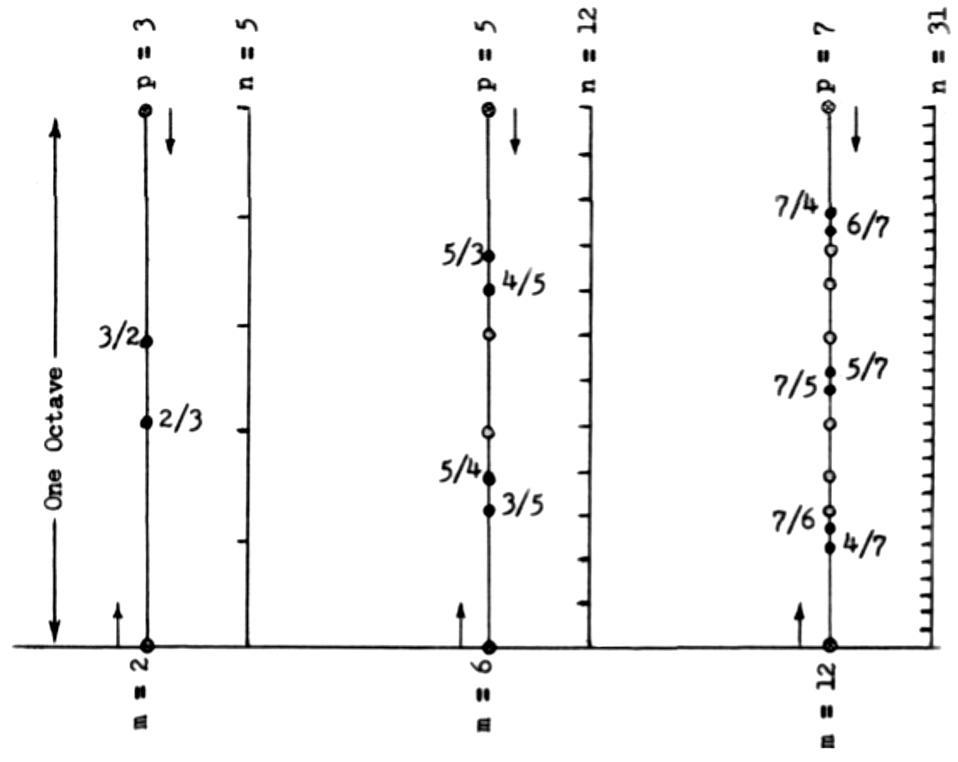Fig. 1: Frequency ratios using numbers up to prime p, to be matched closely (±1/5 interval or less) by a division of the octave into n equal parts, yields three possible chromatic scales: n=5, 12, and 31. ( p=11 would give n=270). m is the total number of ratios, both up from lower base (left) and down from upper octave (right).
Since there is also no preferred direction, we can use the same ratios also downwards, starting one octave above the base. We call m the total of selected tones and define a filling factor by q=m/(n−1). Then n=5 gives q=0.50, n=12 gives q=0.55, and n=31 gives q=0.40. They are again about equally good, but n=270 would give only q=0.10. Thus, some more sensitive civilizations might have gone to n=31, some duller ones to n=5.
Where we draw the line depends mainly on the number of independent channels per octave in the ear, but also on the time-resolution of the audio perception, which both define from which interval-spacing on we hear two tones and their difference-tone instead of one tone with a beat. In general, these audio abilities may follow a distribution with large scatter, but since there is such a wide jump from n=12 to n=31, we might expect that some good fraction of all musical civilizations will draw the line just where we did.
Secondly, if only melody is used but not polyphony, one may pick in a rather arbitrary way any number and sequence of tones out of the 12 provided ones, and will thus arrive at a large variety of more or less equally \good" scales or modes: like the Chinese pentatonic scale, our 12 ecclesiastical modes, and some Indian ones. Thus, not much agreement is to be expected concerning melody alone.
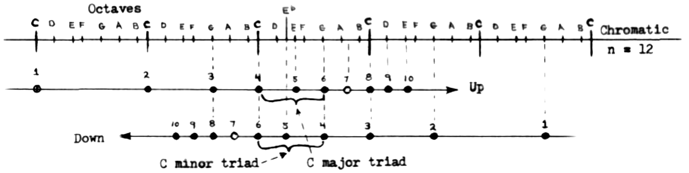Fig 2: There are exactly two possible harmonic chords (if p¸5).
All harmonics of a common fundamental yield major.
All fundamentals of a common harmonic yield minor.
Third, however, in polyphonic music there should be exactly two scales, major and minor. All tones of the major chord are different harmonics of one common fundamental; while all tones of the minor chord are different fundamentals of one common harmonic. And since pitch, as a scalar, has only two directions, up and down, we expect exactly two types of harmonic chords. This holds for n=12 and 31, while there is no difference between major and minor for n=5.
Fourth, drawing the line at p=5 leaves the seventh harmonic as the first omitted one, which leads to some consequences. The first classically permitted dissonant chord is the 7th or septime chord, which follows quite logically if one wants to add the seventh harmonic to the major chord and just takes from the provided tones whichever comes closest (adding B[ to the triad of C major). Following the same principle works also in minor (adding A below the triad of C minor), but this chord is not used so frequently. But another consequence occurs in bagpipe music (a first step to polyphony) with its constant drone, so rich in overtones, and the melody moving above it. The melody usually emphasizes strongly those overtones of the drone which constitute the triad of the major chord, but it somehow tries to use the seventh harmonic, too, again taking whatever comes closest (B[ instead of B if the emphasis is on C major, which also might be described as playing in the key of F major but putting the emphasis on the dominant triad and not its tonal one, and maybe I should call it Mixolydian). Not all the bagpipe pieces show this feature, but about half the pieces I have heard. You can detect this bagpipe scale easily yourself; I, for example, did when I improvised on the flute while my wife worked the vacuum cleaner.
Thus, there seems to be at least some universality in our music, to be expected at least in some other civilizations. But we cannot tell before we have established some contact, and this may take a very long time. Meanwhile, a nice test would be to study the music of different people here on Earth. But is there any well-developed polyphonic music, completely independent from our own? Classical music in India is well-developed but not polyphonic, more like the bagpipe principle of drone and melody, which probably just shows that this principle was already developed before the Indo-European tribes separated; the duduk of old Armenian folk music follows it, too. The National Geographic sells a record called \The Music of Tonga" which contains some interesting music as it was found written down by the first European explorers of this little Polynesian Island. It is truly polyphonic, and indeed seems to contain major, minor, and a strongly emphasized 7th chord. It would be fascinating to search for other examples, if there are any.
In summary, I would expect that many other civilizations in space have no music at all, for biological as well as mental reasons. Some others may have vastly different things they call music but which are incomprehensible for us, for similar reasons. But I do think that some of our basic musical principles are universal enough to be expected at a good fraction of other civilizations: a chromatic scale of exactly 12 parts. from which rather arbitrary scales of smaller number can be selected for melodies, but exactly two harmonic chords, major and minor, for polyphonic music, with the 7th chord as the most important dissonant one. And the same principles may also be expected for independently developed styles of polyphonic music here on Earth.
Recently I heard that there actually is an organ (in the museum at Haarlem, Netherlands) where the octave is divided into 31 equal parts. By the way, doesn't this 31 note scale look like a nice investigation for electronic music? If someone should try, please drop me a note!

